# SQL Project

**Create Table**

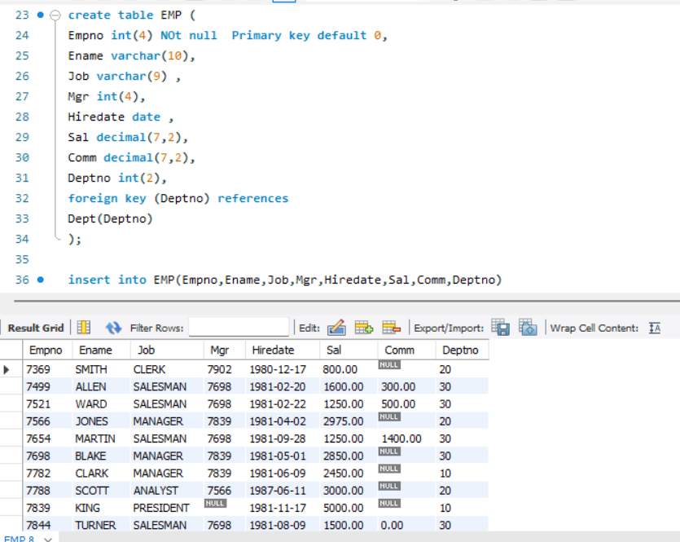

1. **Select unique job from EMP table.**

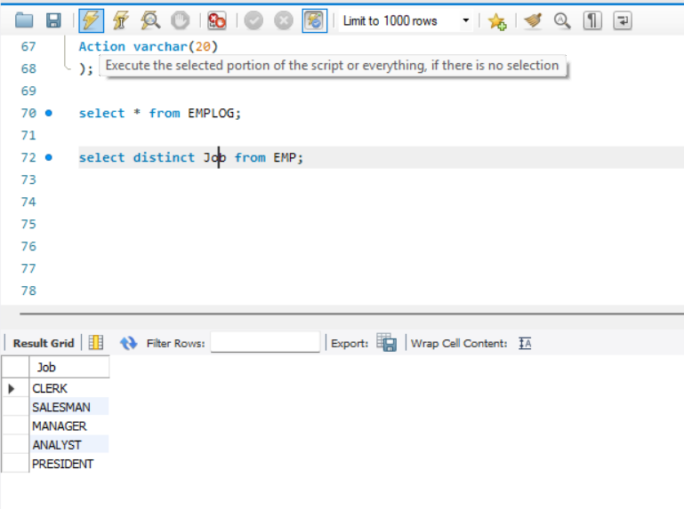

1. **List the details of the emps in asc order of the Dptnos and desc of Jobs?**

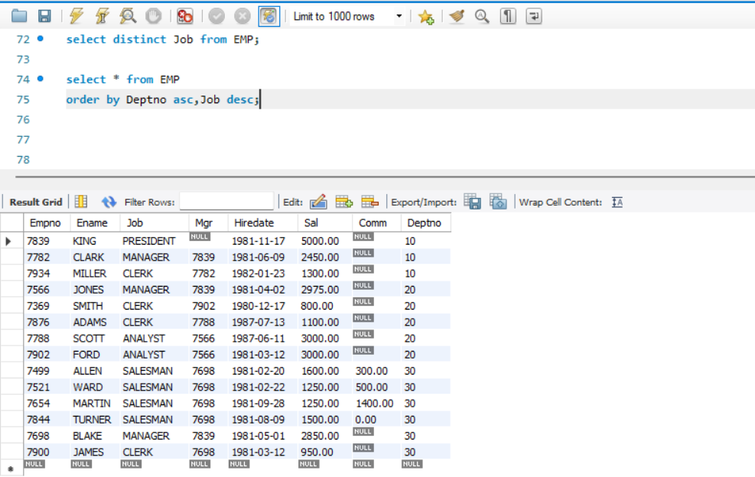

**3.Display all the unique job groups in the descending order?**

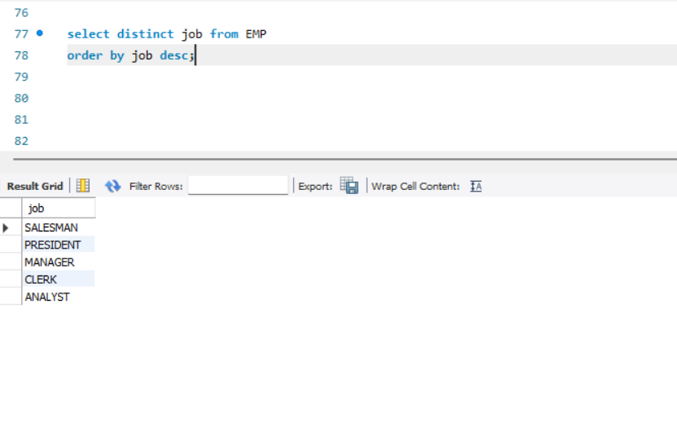

**4.List the emps who joined before 1981.**

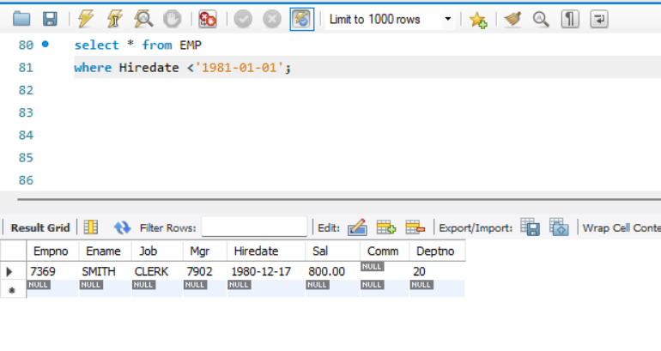

**5.List the Empno, Ename, Sal, Daily sal of all emps in the asc order of Annsal.**

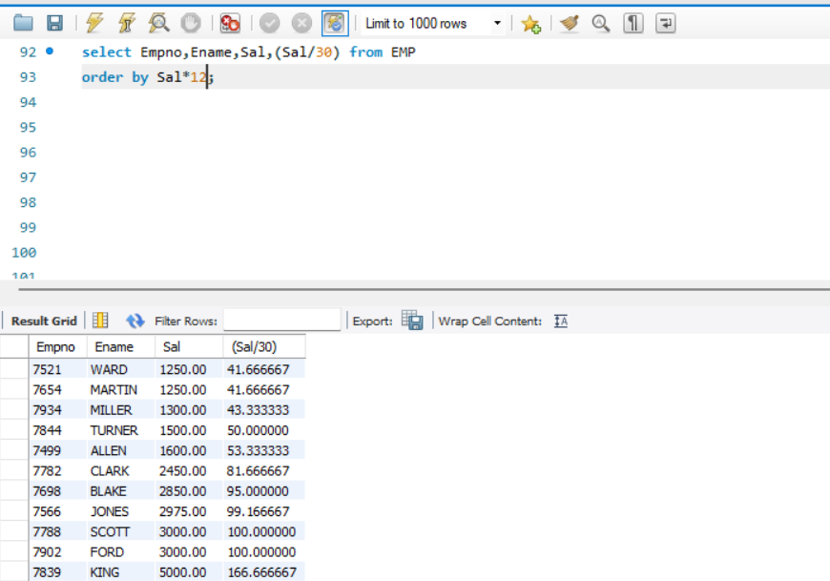

**6. List the Empno, Ename, Sal, Exp of all emps working for Mgr 7369.**

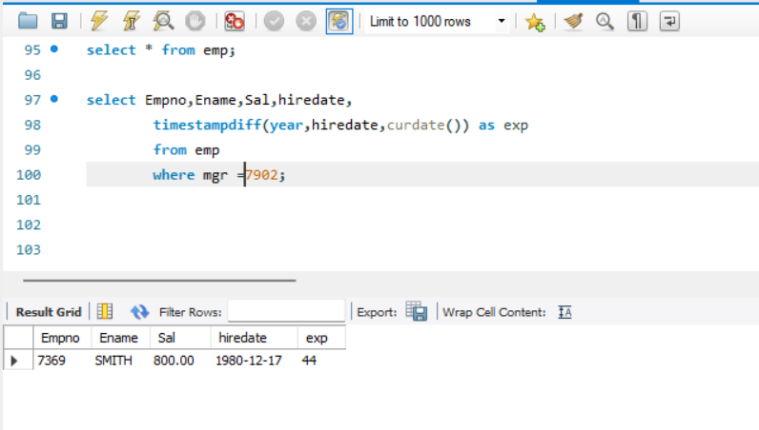

**7.Display all the details of the emps who’s Comm. Is more than their Sal?**

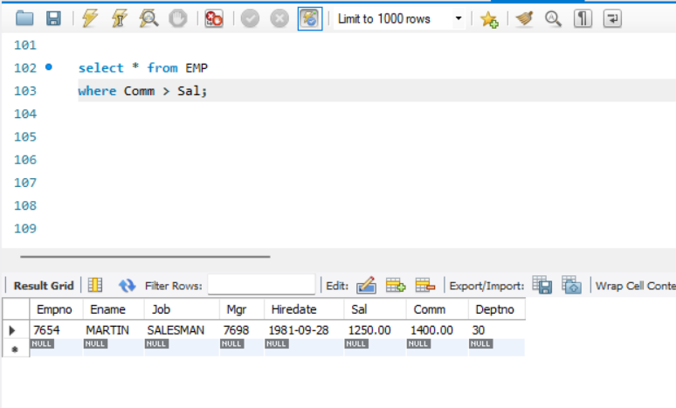

**8. List the emps who are either ‘CLERK’ or ‘ANALYST’ in the Desc order.**

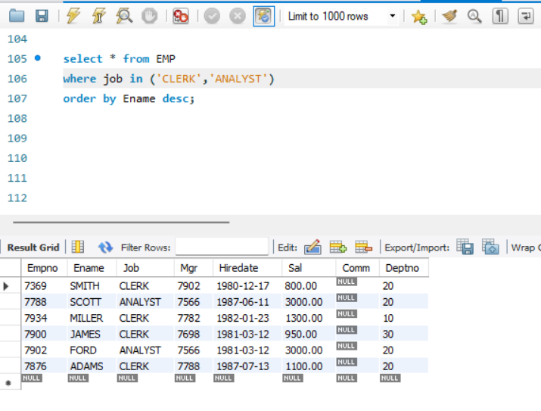

**9. List the emps Who Annual sal ranging from 22000 and 45000.**

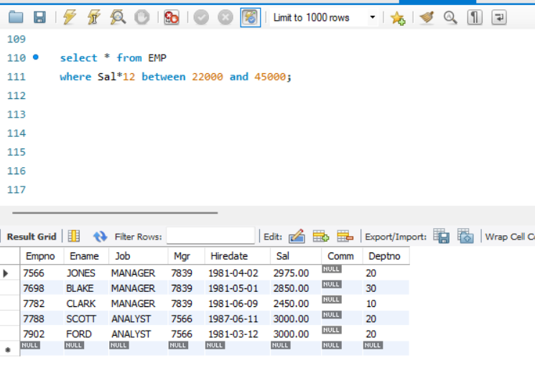

**10. List the Enames those are starting with ‘S’ and with five characters.**

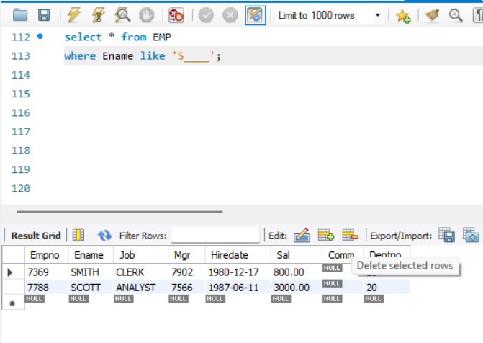

**11. List the emps whose Empno not starting with digit78.**

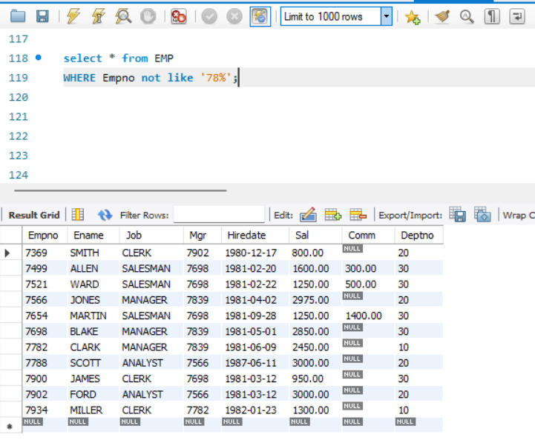

**12. List all the Clerks of Deptno 20.**

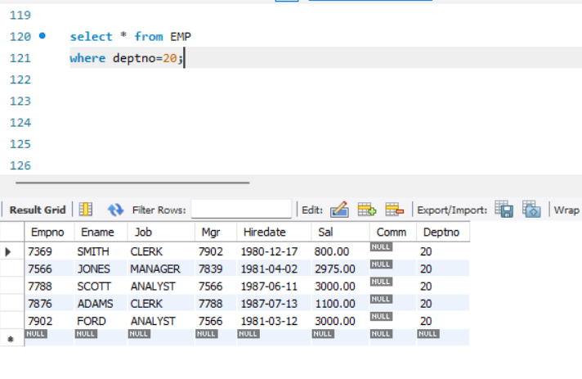

**13. List the Emps who are senior to their own MGRS.**

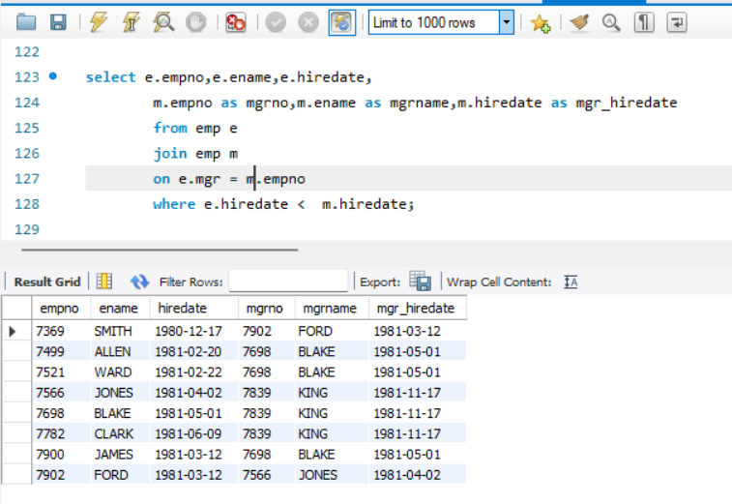

**14. List the Emps of Deptno 20 who’s Jobs are same as Deptno10.**

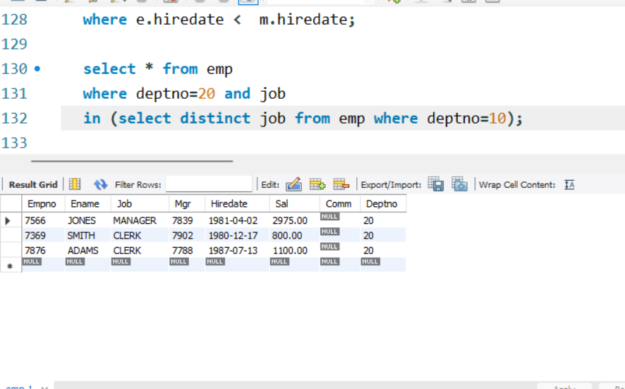

**15. List the Emps who’s Sal is same as FORD or SMITH in desc order of Sal.**

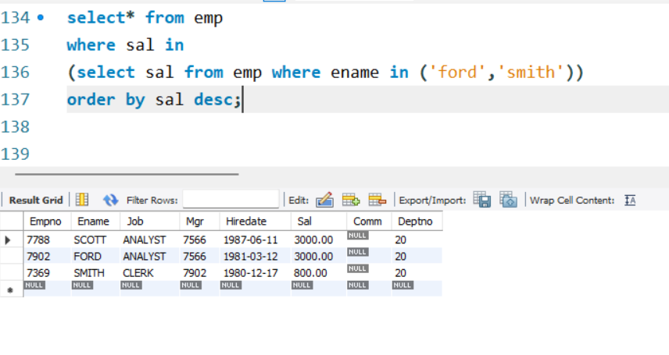

**16. List the emps whose jobs same as SMITH or ALLEN.**

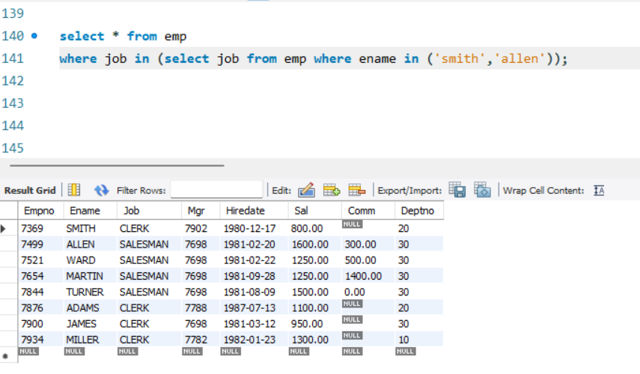

**17. Any jobs of deptno 10 those that are not found in deptno 20.**

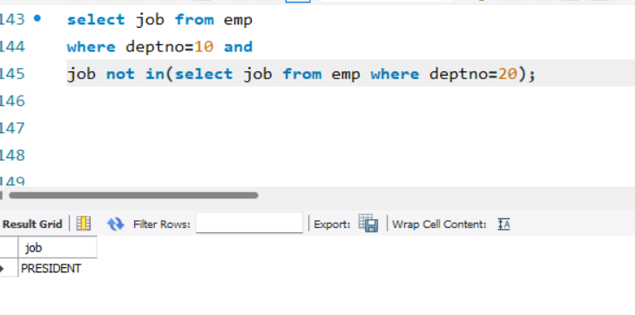

**18. Find the highest sal of EMP table.**

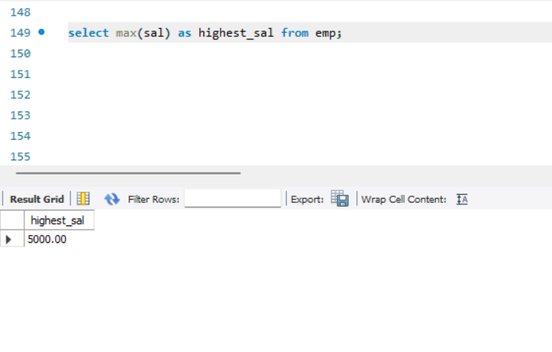

**19.Find details of highest paid employee.**

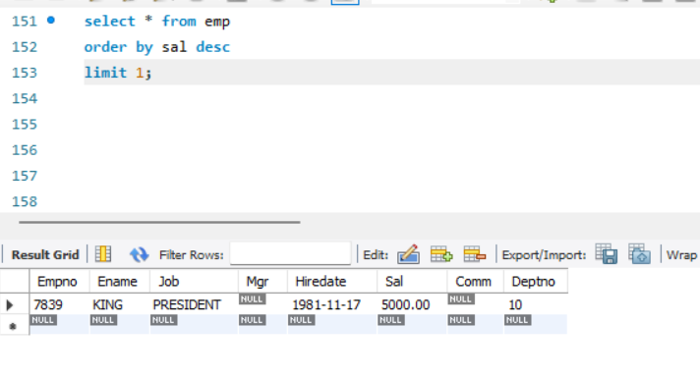

**20. Find the total sal given to the MGR.**

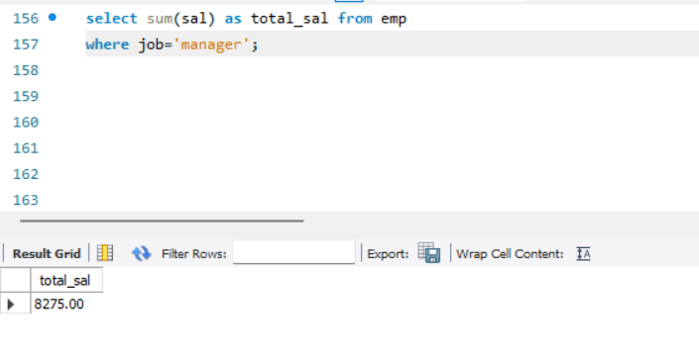

**21. List the emps whose names contains ‘A’.**

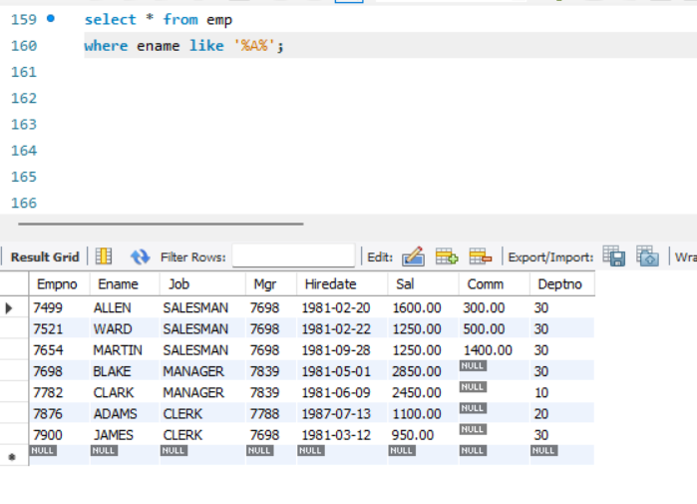

**22. Find all the emps who earn the minimum Salary for each job wise in ascending order.**

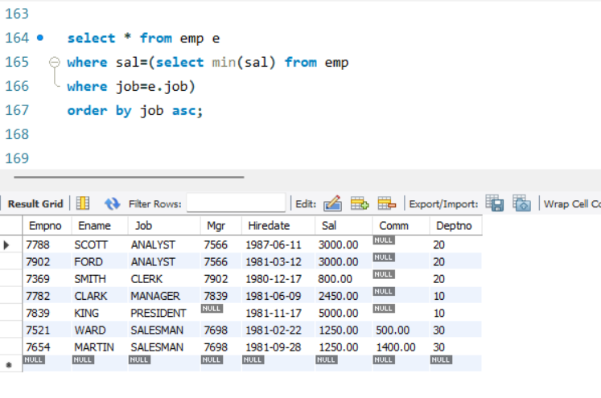

**23. List the emps whose sal greater than Blake’s sal.**

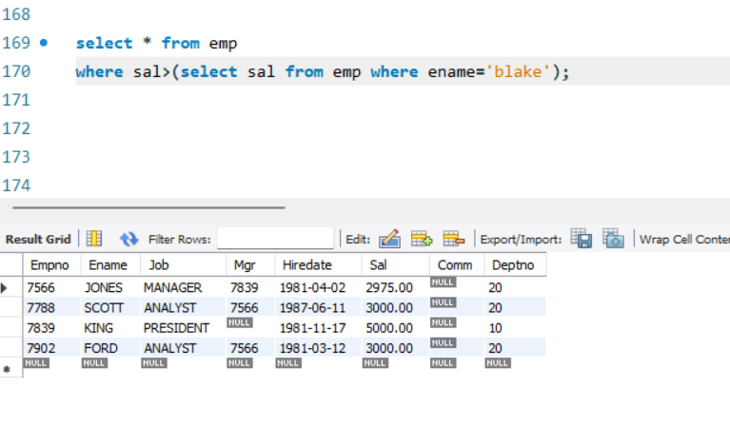

**24.Create view v1 to select ename, job, dname, loc whose deptno are same.**

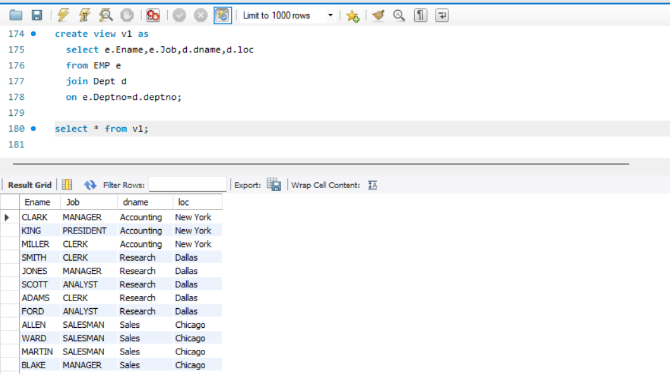

**25.Create a procedure with dno as input parameter to fetch ename and dname.**

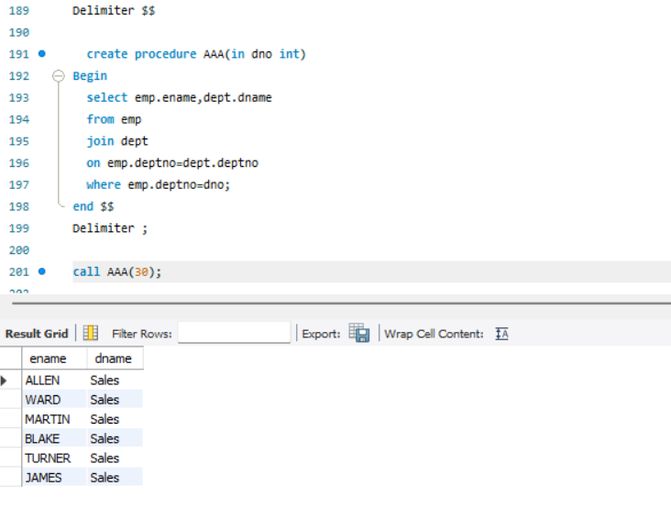

**26. Add column Pin with bigint data type in table student.**

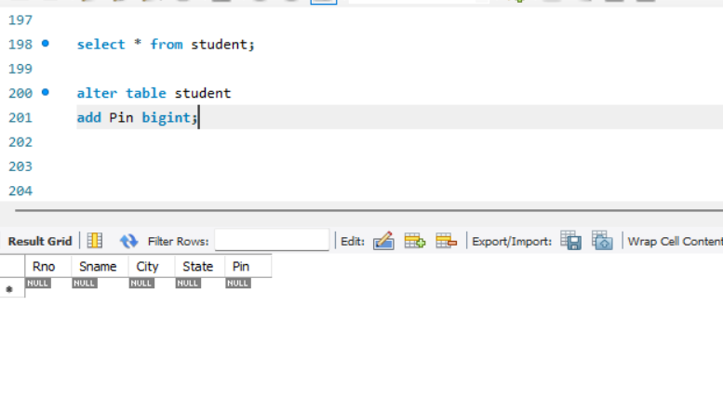

**27. Modify the student table to change the sname length from 14 to 40. Create trigger to insert data in emp_log table whenever any update of sal in EMP table. You can set action as ‘New Salary’.**

